Hotel SMK Negeri 2 Gorontalo
Jl.Diponegoro, Kel. Limba U2 . Kota Gorontalo Indonesia
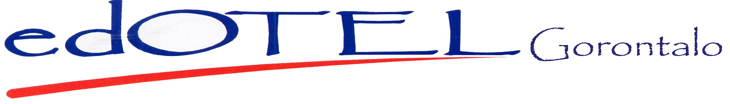
Tel. No: 08981119988

HOTEL REGISTRATION FORM

Surname: __________________________
First Name: ________________________
Address: _______________________________________________________________________________
_______________________________________________________________________________
Country: ______________ Postal Code: ___________________
Phone:_______________ E-mail: _______________________
Passport / ID No: ______________________ Fax : ___________________________________________
Credit Card : American Express Master Card Visa Dinner Club Others_________

Credit Card Number : __________________ Exp.Date : ____________ / ___________

Guarrantee : __________________________ Deposit : ______________________

Arrival Date: _________________________ Departure Date: _______________ Total: ______nights
Card holder Name: ____________________ Signature : ____________________ Date: _______
Room Type : ___________ Room. No : ____________ Room Rate : ______________________
Remarks : ______________________________________________________________________________
______________________________________________________________________________
______________________________________________________________________________
______________________________________________________________________________
Dear Guest, please note the following / Dengan hormat mohon diperhatikan
- Check out time is 12.00 noon and chec in time is 14.00 hrs/ waktu keberangkatan pada pukul 12 siang dan waktu kedatangan pada pukul 14.00
- The hotel will ot held responsiblefor lost of money or valuable left in the room, safety deposit boxes are available at Front desk and free of charge /
Hotel tidak beryangung jawab atas kehilangan uang atau barang berharga yang ada didalam kamar, kotak penyimpanan tersedia di meja depan secara Cuma-Cuma.
- Room sates are subject to 10% service charge and 11% prevailling goverment tax / Harga kamar belum termasuk 10% pelayanan dan 11% pajak
pemeritah yang berlaku
Guest Signature / Tanda tangan tamu

Regardess of charge instructions, I hearby acknowledge to be perspnally responsible for the payment of my accounts / Dengan mengabulkan instruksi penagihan yang ada, saya mengetahui bahwa saya pribadi akan bertanggung jawab atas seluruh pembayaran

Front Desk Agent

Initial & signature

